# Currency, Grocery Services

## Maven packaging, create docker images

### discovery-service

cd C:\Ravi\Workspaces\myworkspace_git\ms-reskill\discovery-service

mvn clean install -DskipTests

docker build -t discoveryservice:1.0 .

### manage-currency-conversion-factor-service

cd C:\Ravi\Workspaces\myworkspace_git\ms-reskill\manage-currency-conversion-factor-service

mvn clean install -DskipTests

docker build -t manage-currency-conversion-factor-service:1.0 .

### currency-conversion-service

cd C:\Ravi\Workspaces\myworkspace_git\ms-reskill\currency-conversion-service

mvn clean install -DskipTests

docker build -t currency-conversion-service:1.0 .

### grocery-store-service

cd C:\Ravi\Workspaces\myworkspace_git\ms-reskill\grocery-store-service

mvn clean install -DskipTests

docker build -t grocerystoreservice:1.0 .

## Image Listing

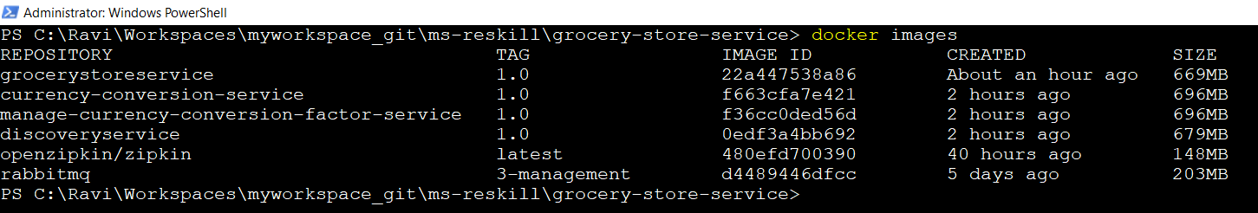

## Run Images

docker run -d --name localhost -p 5672:5672 -p 5673:5673 -p 15672:15672 rabbitmq:3-management

SET RABBIT_URI=amqp://localhost

docker run -d -p 9411:9411 openzipkin/zipkin

### Currency, Product services images

docker run -d -p 9002:9002 -t discoveryservice:1.0

docker run -d -p 8020:8020 -t manage-currency-conversion-factor-service:1.0

docker run -d -p 8030:8030 -t currency-conversion-service:1.0

docker run -d -p 8080:8080 -t grocerystoreservice:1.0

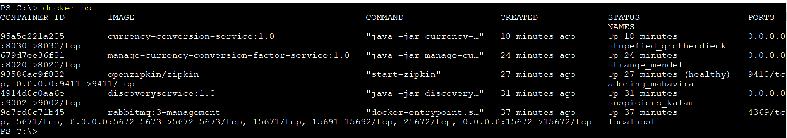

## Docker Push

docker tag 0edf3a4bb692 rabonkup/discoveryservice:1.0

docker push rabonkup/discoveryservice:1.0

docker tag f36cc0ded56d rabonkup/managecurrencyconversionfactorservice:1.0

docker push rabonkup/managecurrencyconversionfactorservice:1.0

docker tag f663cfa7e421 rabonkup/currencyconversionservice:1.0

docker push rabonkup/currencyconversionservice:1.0

docker tag 22a447538a86 rabonkup/grocerystoreservice:1.0

docker push rabonkup/grocerystoreservice:1.0

